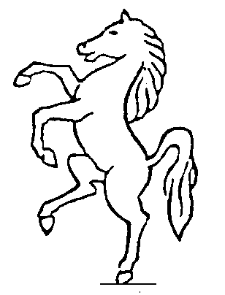
KENT COUNTY
SHORT MAT BOWLING ASSOCIATION

***************************AFFILIATED TO E.S.M.B.A.**************************
Registration form for members 2019/ 2020

Club Name________________________________Club Contact________________________________

Contact Address______________________________________________________________________

Contact Tel+Email_____________________________________________________________________

Please include club registration fee….£25 if 5 or more members, £30 if 4 or less

 | Title  Mr/Mrs etc | Christian Name | Surname | Email | Telephone | U18 Please tickwhere appropriate | Adult Please tick where appropriate | Are you on Facebook (Y/N)
1
2
3
4
5
6
7
8
9
10
11
12
13
14
15
16
17
18
19
20
21
22
23
24
25
26
27
28
29

To avoid discrepancy with points please ensure information is given in full.
If a member wishes to be known by an abbreviated name please keep same name in all places.
Adult member - £10
Under 18 – Free
All cheques made payable to K.C.S.M.B.A
Please return to Secretary no later than 31st August

Linda Wynn
74 Castle Drive
Kemsing
Sevenoaks
Kent, TN15 6RS linda2@btinternet.com

If more pages are required please reprint a page

